Yelp: <https://www.yelp.com/biz/queens-chopstick-corvallis>

About: Opened since 2010. Providing the most authentic Chinese Food in Corvallis. The ingredients we use are the freshest, in order to give you the most delicious cuisine. Quickly, invite you best friends to hold a reunion here to find the familiar taste from your hometown.

Scallion Pancake $6.50

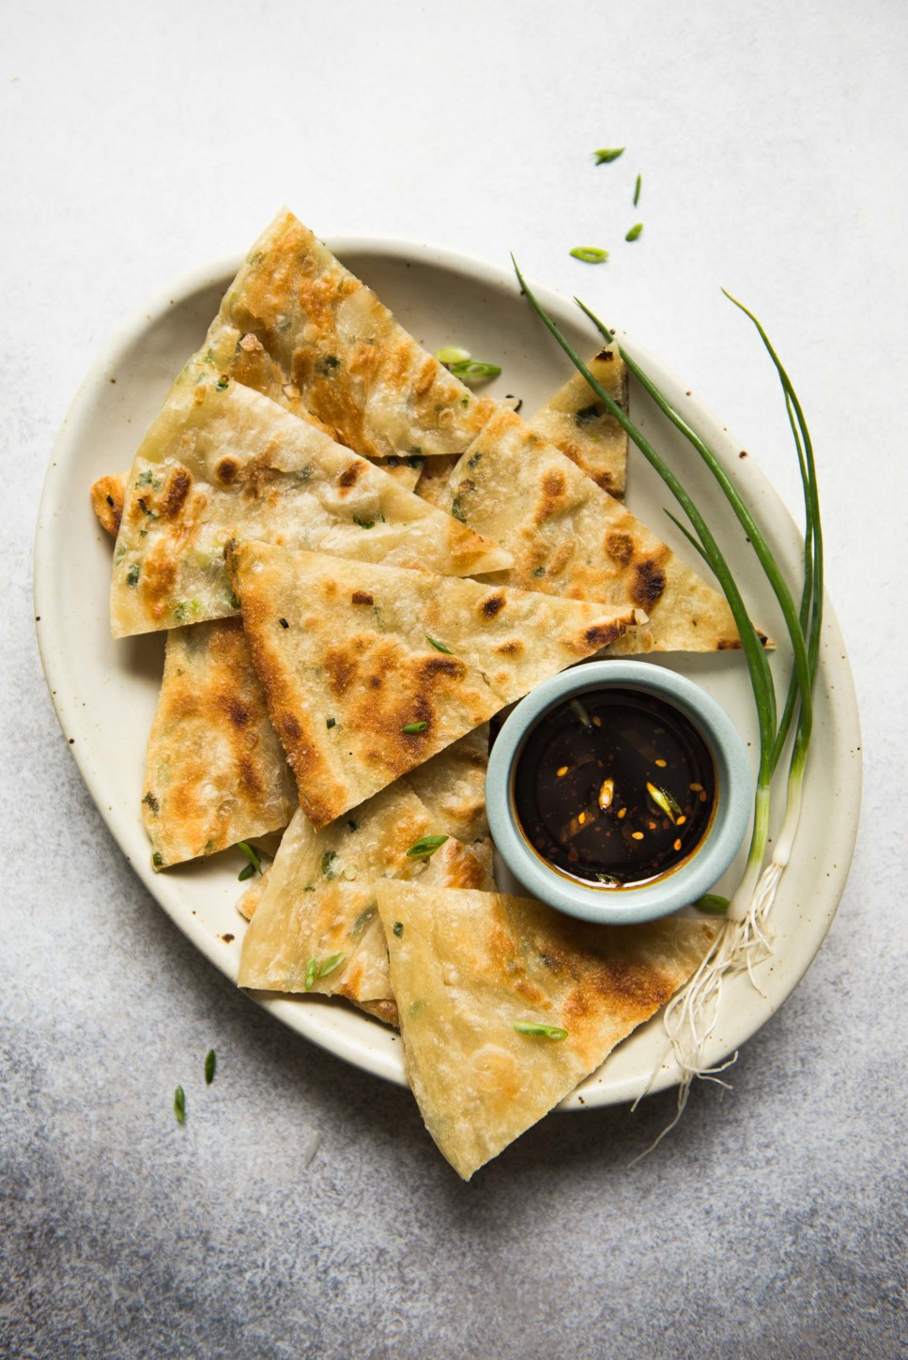

Bar-B-Q Pork $6.95

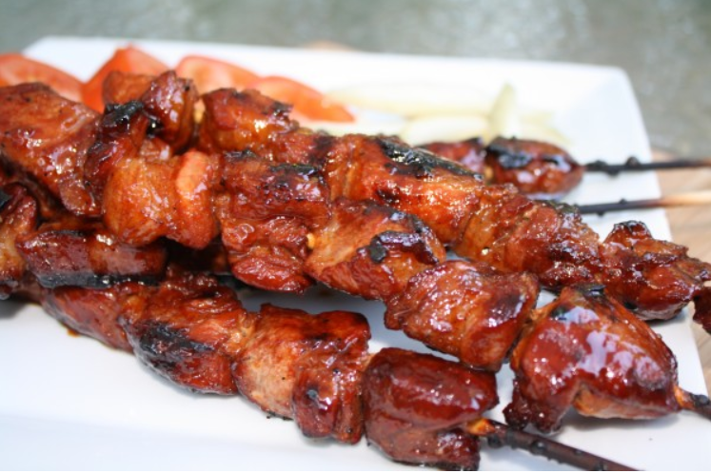

Egg Flower Soup (S) $2.50 (L) $4.95

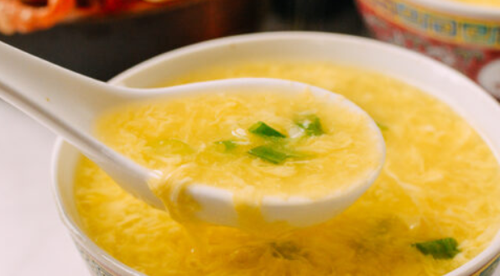

House Lo Mein $12.95

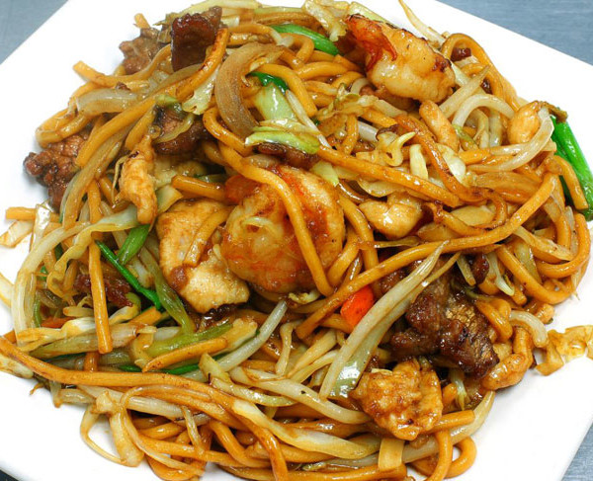

Penang Grilled Prawn $15.95

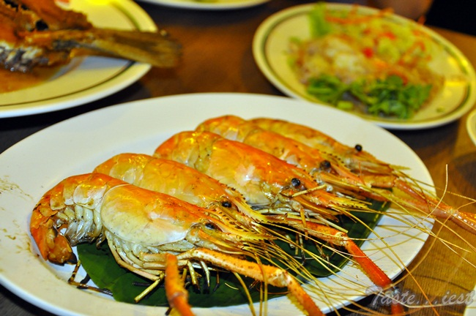

Prawns with Lobster Sauce $14.95

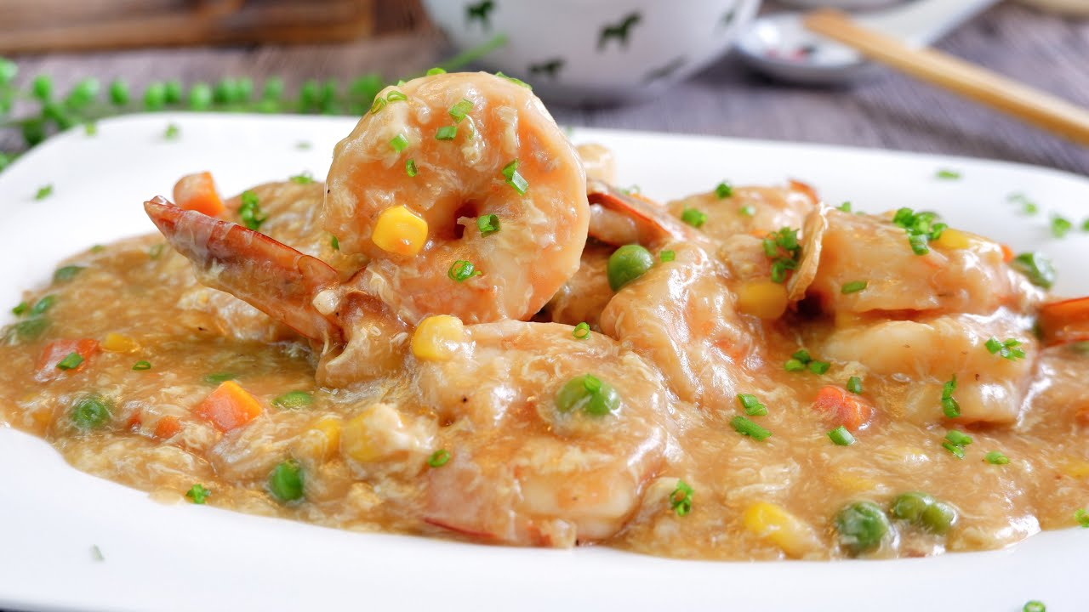

Mixed Vegetables $11.95

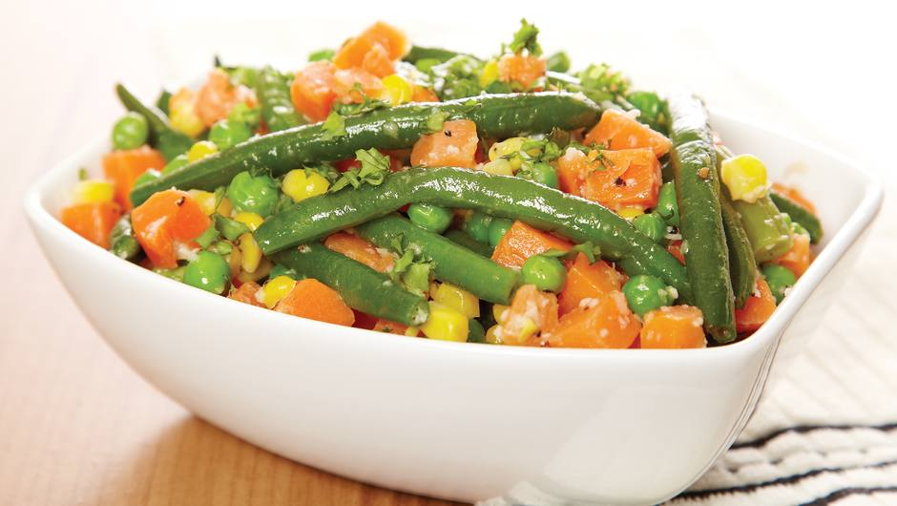

Chicken Dumplings (8) $6.95

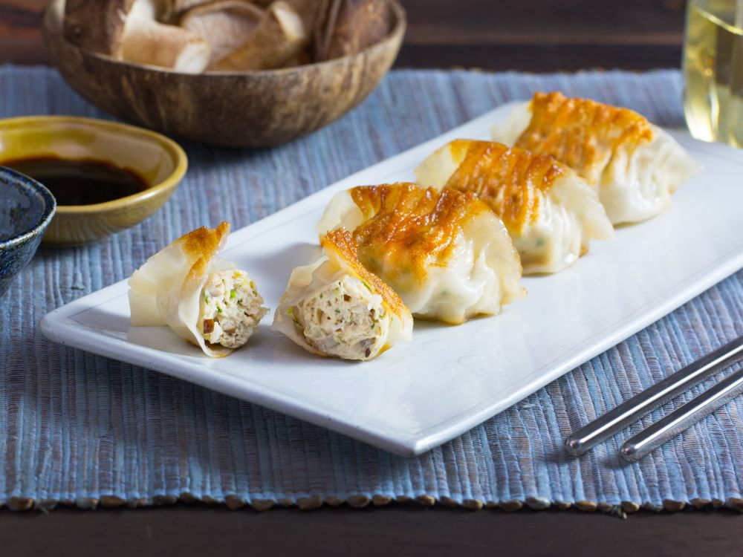

Queen's Chicken Lettuce Wraps $14.50

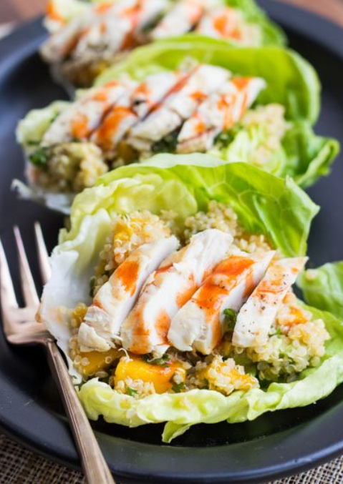

Sesame Shrimp $14.95

